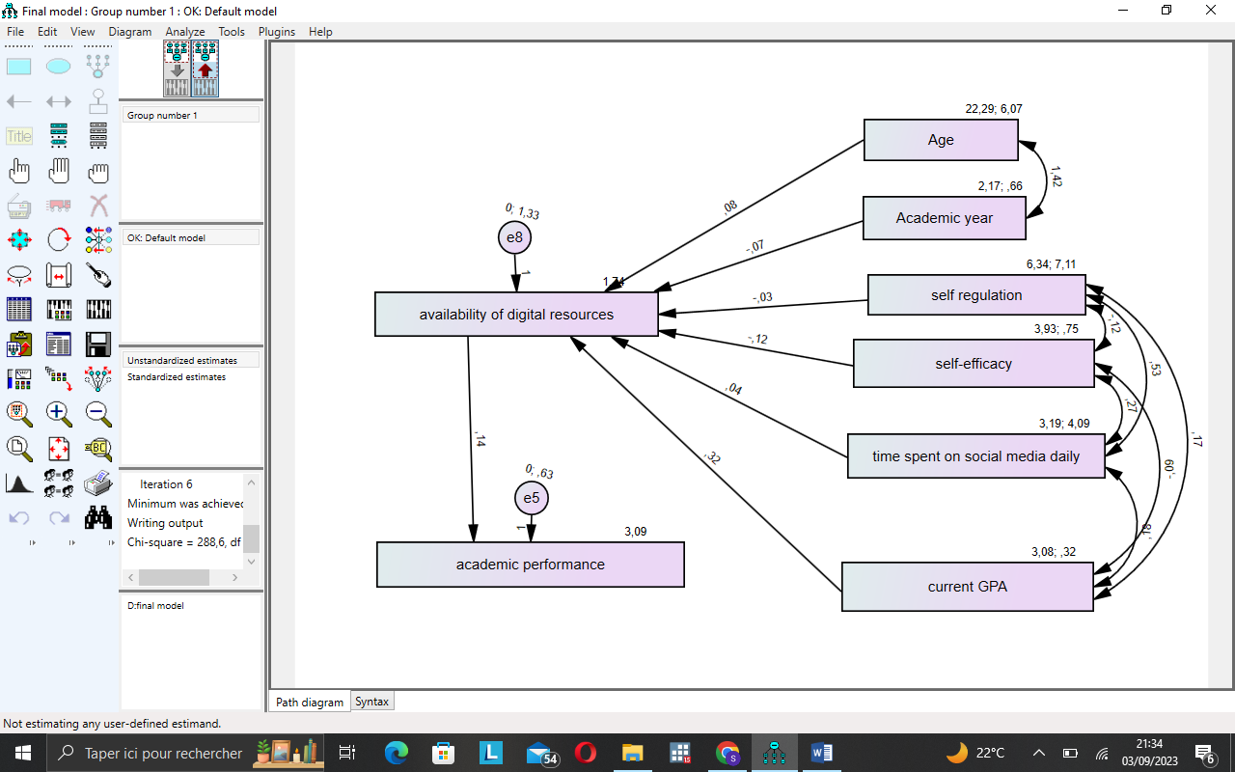

Final model

**Result (Default model)**

Minimum was achieved

Chi-square = 288,559

Degrees of freedom = 14

Probability level = ,000

## Correlations: (Group number 1 - Default model)

|  |  |  | **Estimate** |
| --- | --- | --- | --- |
| Academicyear | <--> | Age | ,711 |
| selfefficacy | <--> | timespentonsocialmediadaily | ,153 |
| timespentonsocialmediadaily | <--> | currentGPA | ,163 |
| selfefficacy | <--> | selfregulation | -,050 |
| selfefficacy | <--> | currentGPA | -,182 |
| currentGPA | <--> | selfregulation | ,111 |
| timespentonsocialmediadaily | <--> | selfregulation | ,098 |

## Covariances: (Group number 1 - Default model)

|  |  |  | **Estimate** | **S.E.** | **C.R.** | **P** | **Label** |
| --- | --- | --- | --- | --- | --- | --- | --- |
| Academicyear | <--> | Age | 1,424 | ,184 | 7,751 | *** | par_1 |
| selfefficacy | <--> | timespentonsocialmediadaily | ,268 | ,132 | 2,024 | ,043 | par_2 |
| timespentonsocialmediadaily | <--> | currentGPA | ,185 | ,086 | 2,148 | ,032 | par_3 |
| selfefficacy | <--> | selfregulation | -,116 | ,173 | -,672 | ,501 | par_4 |
| selfefficacy | <--> | currentGPA | -,088 | ,037 | -2,391 | ,017 | par_5 |
| currentGPA | <--> | selfregulation | ,166 | ,113 | 1,472 | ,141 | par_6 |
| timespentonsocialmediadaily | <--> | selfregulation | ,530 | ,405 | 1,310 | ,190 | par_7 |

**Regression Weights: (Group number 1 - Default model)**

|  |  |  | **Estimate** | **S.E.** | **C.R.** | **P** | **Label** |
| --- | --- | --- | --- | --- | --- | --- | --- |
| availabilityofdigitalresources | <--- | Age | ,078 | ,050 | 1,560 | ,119 | par_8 |
| availabilityofdigitalresources | <--- | Academicyear | -,072 | ,151 | -,476 | ,634 | par_9 |
| availabilityofdigitalresources | <--- | selfregulation | -,027 | ,033 | -,833 | ,405 | par_10 |
| availabilityofdigitalresources | <--- | selfefficacy | -,119 | ,103 | -1,149 | ,250 | par_11 |
| availabilityofdigitalresources | <--- | timespentonsocialmediadaily | ,043 | ,044 | ,971 | ,332 | par_12 |
| availabilityofdigitalresources | <--- | currentGPA | ,323 | ,160 | 2,015 | ,044 | par_13 |
| academicperformance | <--- | availabilityofdigitalresources | ,138 | ,050 | 2,763 | ,006 | par_14 |

**Standardized Regression Weights: (Group number 1 - Default model)**

|  |  |  | **Estimate** |
| --- | --- | --- | --- |
| availabilityofdigitalresources | <--- | Age | ,161 |
| availabilityofdigitalresources | <--- | Academicyear | -,049 |
| availabilityofdigitalresources | <--- | selfregulation | -,061 |
| availabilityofdigitalresources | <--- | selfefficacy | -,087 |
| availabilityofdigitalresources | <--- | timespentonsocialmediadaily | ,073 |
| availabilityofdigitalresources | <--- | currentGPA | ,152 |
| academicperformance | <--- | availabilityofdigitalresources | ,203 |

THEORY AND INDEP VAR

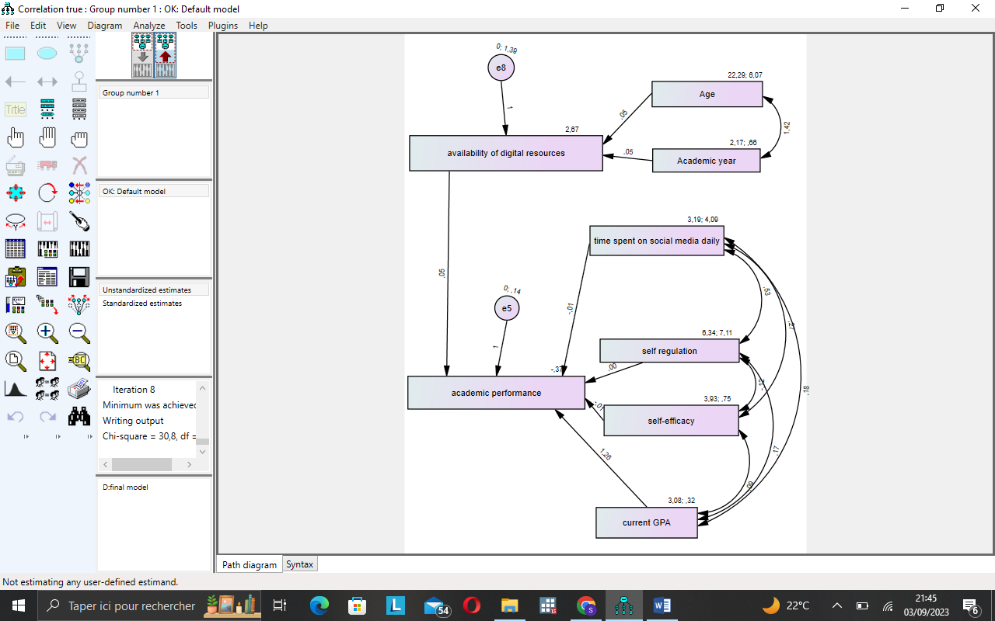

CHI SQUARE :30.786

DEGREES OF FREEDOM: 14

PROBABILITY LEVEL: .006

**Regression Weights: (Group number 1 - Default model)**

|  |  |  | **Estimate** | **S.E.** | **C.R.** | **P** | **Label** |
| --- | --- | --- | --- | --- | --- | --- | --- |
| availabilityofdigitalresources | <--- | Age | ,047 | ,051 | ,914 | ,361 | par_8 |
| availabilityofdigitalresources | <--- | Academicyear | ,048 | ,154 | ,310 | ,757 | par_9 |
| academicperformance | <--- | selfefficacy | -,014 | ,034 | -,424 | ,671 | par_10 |
| academicperformance | <--- | currentGPA | 1,260 | ,052 | 23,995 | *** | par_11 |
| academicperformance | <--- | availabilityofdigitalresources | ,048 | ,024 | 1,999 | ,046 | par_12 |
| academicperformance | <--- | selfregulation | ,004 | ,011 | ,381 | ,703 | par_13 |
| academicperformance | <--- | timespentonsocialmediadaily | -,015 | ,015 | -1,032 | ,302 | par_14 |

**Standardized Regression Weights: (Group number 1 - Default model)**

|  |  |  | **Estimate** |
| --- | --- | --- | --- |
| availabilityofdigitalresources | <--- | Age | ,097 |
| availabilityofdigitalresources | <--- | Academicyear | ,033 |
| academicperformance | <--- | selfefficacy | -,015 |
| academicperformance | <--- | currentGPA | ,880 |
| academicperformance | <--- | availabilityofdigitalresources | ,071 |
| academicperformance | <--- | selfregulation | ,014 |
| academicperformance | <--- | timespentonsocialmediadaily | -,038 |

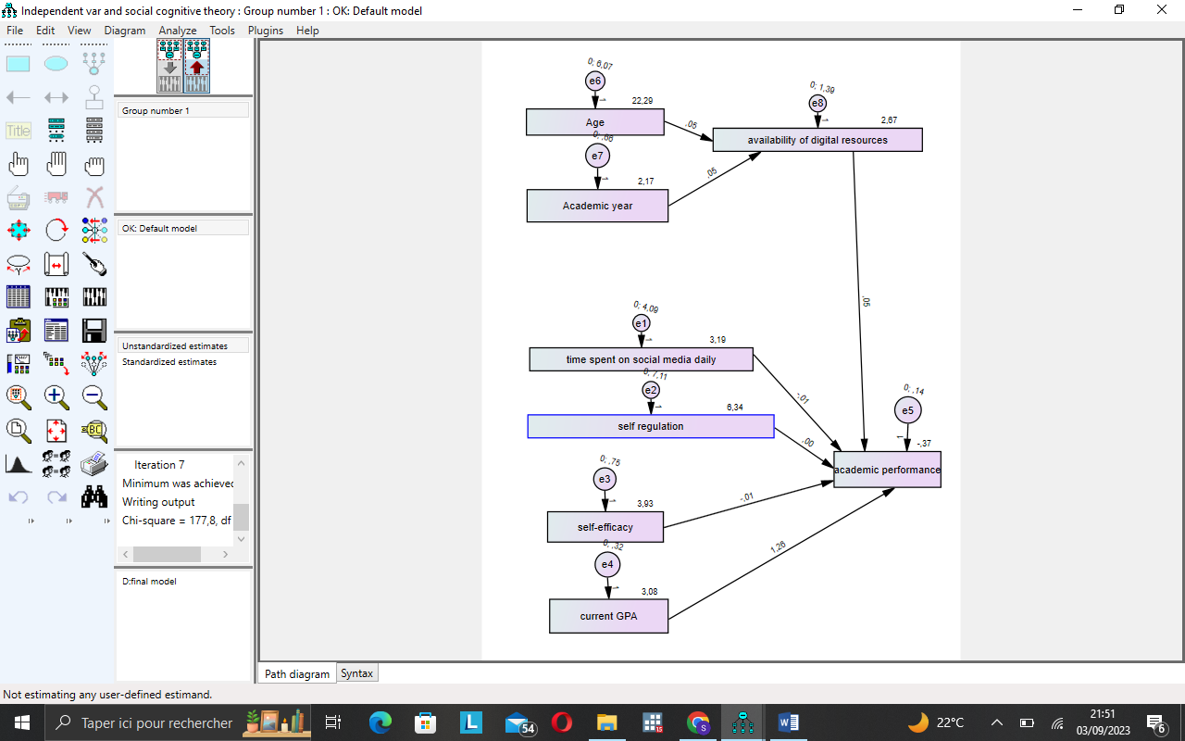

CHI SQUARE :177.803

DEGREES OF FREEDOM: 21

PROBABILITY LEVEL: .000

**Regression Weights: (Group number 1 - Default model)**

|  |  |  | **Estimate** | **S.E.** | **C.R.** | **P** | **Label** |
| --- | --- | --- | --- | --- | --- | --- | --- |
| availabilityofdigitalresources | <--- | Age | ,047 | ,036 | 1,300 | ,194 | par_6 |
| availabilityofdigitalresources | <--- | Academicyear | ,048 | ,108 | ,440 | ,660 | par_7 |
| academicperformance | <--- | selfefficacy | -,014 | ,033 | -,440 | ,660 | par_1 |
| academicperformance | <--- | currentGPA | 1,260 | ,050 | 24,972 | *** | par_2 |
| academicperformance | <--- | selfregulation | ,004 | ,011 | ,385 | ,700 | par_3 |
| academicperformance | <--- | timespentonsocialmediadaily | -,015 | ,014 | -1,069 | ,285 | par_4 |
| academicperformance | <--- | availabilityofdigitalresources | ,048 | ,024 | 1,995 | ,046 | par_5 |

**Standardized Regression Weights: (Group number 1 - Default model)**

|  |  |  | **Estimate** |
| --- | --- | --- | --- |
| availabilityofdigitalresources | <--- | Age | ,097 |
| availabilityofdigitalresources | <--- | Academicyear | ,033 |
| academicperformance | <--- | selfefficacy | -,015 |
| academicperformance | <--- | currentGPA | ,878 |
| academicperformance | <--- | selfregulation | ,014 |
| academicperformance | <--- | timespentonsocialmediadaily | -,038 |
| academicperformance | <--- | availabilityofdigitalresources | ,070 |

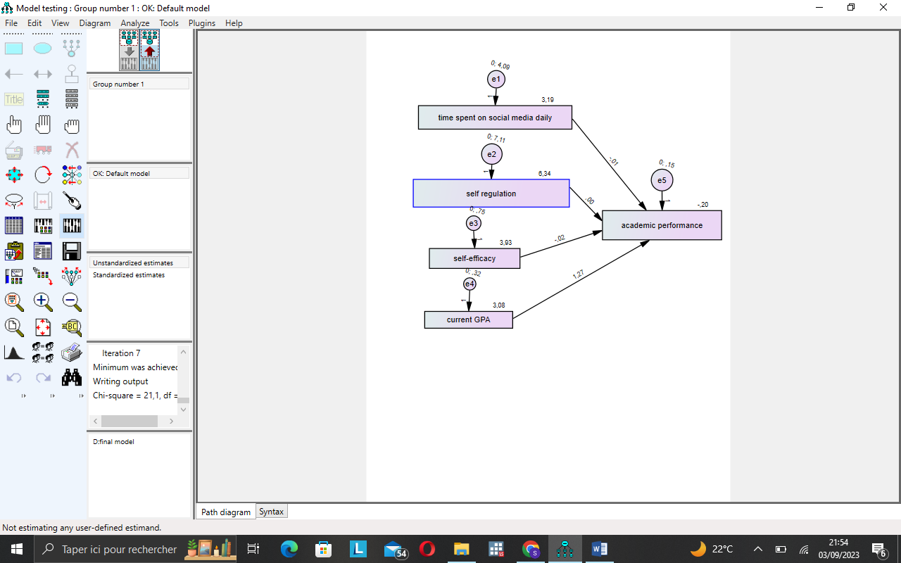

CHI SQUARE :21.013

DEGREES OF FREEDOM: 6

PROBABILITY LEVEL: .002

**Regression Weights: (Group number 1 - Default model)**

|  |  |  | **Estimate** | **S.E.** | **C.R.** | **P** | **Label** |
| --- | --- | --- | --- | --- | --- | --- | --- |
| academicperformance | <--- | selfregulation | ,003 | ,011 | ,235 | ,814 |  |
| academicperformance | <--- | selfefficacy | -,020 | ,033 | -,595 | ,552 |  |
| academicperformance | <--- | currentGPA | 1,274 | ,051 | 24,979 | *** |  |
| academicperformance | <--- | timespentonsocialmediadaily | -,013 | ,014 | -,921 | ,357 |  |

**Standardized Regression Weights: (Group number 1 - Default model)**

|  |  |  | **Estimate** |
| --- | --- | --- | --- |
| academicperformance | <--- | selfregulation | ,008 |
| academicperformance | <--- | selfefficacy | -,021 |
| academicperformance | <--- | currentGPA | ,881 |
| academicperformance | <--- | timespentonsocialmediadaily | -,032 |

**Group number 1 (Group number 1 - Default model)**

**Estimates (Group number 1 - Default model)**

**Scalar Estimates (Group number 1 - Default model)**

**Maximum Likelihood Estimates**

**Regression Weights: (Group number 1 - Default model)**